Chapter 4, Problem 55.

Obtain the Norton equivalent at terminals a-b of the circuit in Fig. 4.121.
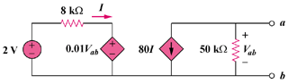
0.001

Figure 4.121
For Prob. 4.55.

